**Python Assignment Programs**

**T Raja Aadhithan**

**19/1031**

**Program 1:**

**CODE:**

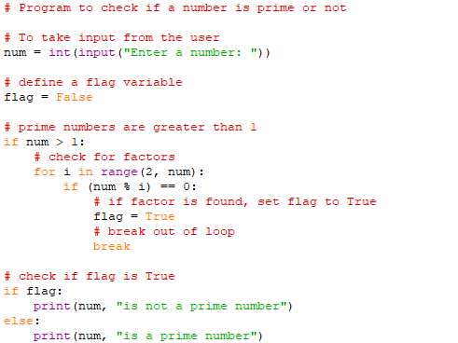

**OUTPUT:**

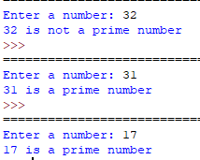

**Program 2:**

**CODE:**

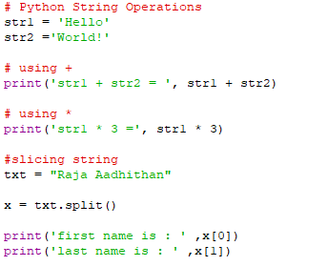

**OUTPUT:**

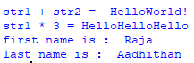

**Program 3:** Python program that accepts a string and calculate the number of digits and letters.

**CODE:**

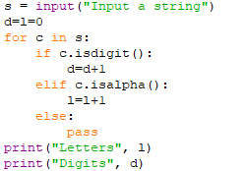

**OUTPUT:**

